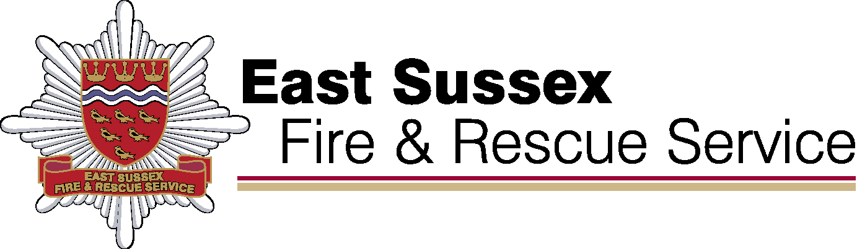

**East Sussex Fire & Rescue**

**Performance Results**

**Quarter 4 2022/23and year end results.**

July 2023

**Our Purpose**

**We make our communities safer**

**We will do this by:**

**Commitment 1: Delivering high performing services**



**We make our communities safer**

**We will do this by:**

**Commitment 2: Educating our communities**



**We make our communities safer**

**We will do this by:**

**Commitment 3: Developing a multi-skilled, safe and valued workforce**



**We make our communities safer**

**We will do this by:**

**Commitment 4: Making effective use of our resources**

