Clutter Image Rating (CIR) – BEDROOM
Please select the CIR which closely relates to the amount of clutter
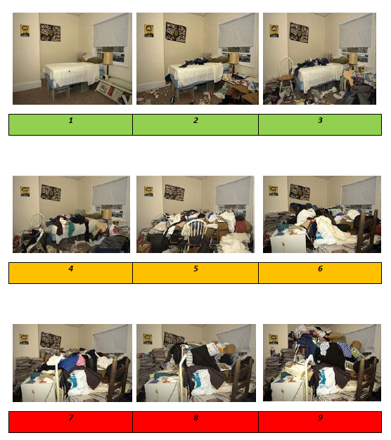

Clutter Image Rating (CIR) – LOUNGE
Please select the CIR which closely relates to the amount of clutter

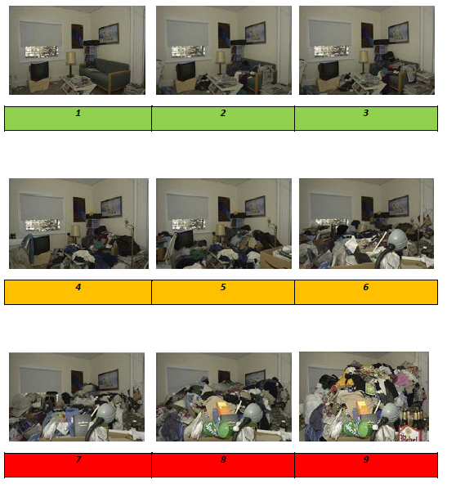

Clutter Image Rating (CIR) – KITCHEN
Please select the CIR which closely relates to the amount of clutter

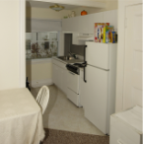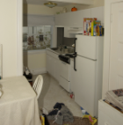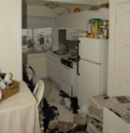
1 | 2 | 3

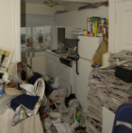
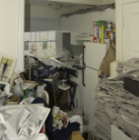
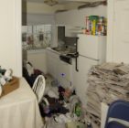

4 | 5 | 6

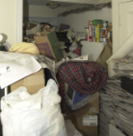
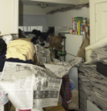
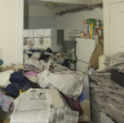

7 | 8 | 9

20. Description of Risk - Level One

Level 1 Clutter image rating 1 - 3 | Household environment is considered standard. No specialised assistance is needed. If the resident would like some assistance with general housework or feels they are declining towards a higher clutter scale, appropriate referrals can be made subject to circumstances.
1. Property structure, services & garden area | - All entrances and exits, stairways, roof space and windows accessible.  - Smoke alarms fitted and functional or referrals made to East Sussex Fire and Rescue Service to visit and install if criteria met.  - All services functional and maintained in good working order.  - Garden is accessible, tidy and maintained
2. Household Functions | - No excessive clutter, all rooms can be safely used for their intended purpose.  - All rooms are rated 0-3 on the Clutter Rating Scale.  - No additional unused household appliances appear in unusual locations around the property.  - Property is maintained within terms of any lease or tenancy agreements where appropriate.  - Property is not at risk of action by Environmental Health.
3. Health and Safety | - Property is clean with no odours, (pet or other).  - No rotting food.  - No concerning use of candles.  - No concern over flies.  - Residents managing personal care.  - No writing on the walls.  - Quantities of medication are within appropriate limits, in date and stored appropriately.
4.Safeguard of Children & Family members | - No concerns for household members.
5. Animals and Pests | - Any pets at the property are well cared for.  - No pests or infestations at the property.
6. Personal Protective Equipment (PPE) | - No PPE required.  - No visit in pairs required.

Description of Risk - Level Two

Level 2  Clutter Image Rating 4 – 6 | Household environment requires professional assistance to resolve the clutter and the maintenance issues in the property.
1. Property structure, services & garden area | - Only major exit is blocked.  - Concern that services are not well maintained.  - Smoke alarms are not installed or not functioning.  - Garden is not accessible due to clutter, or is not maintained  - Evidence of indoor items stored outside.  - Evidence of light structural damage including damp.  - Interior doors missing or blocked open.
2. Household Functions | - Clutter is causing congestion in the living spaces and is  impacting on the use of the rooms for their intended purpose.  - Clutter is causing congestion between the rooms and  entrances.  - Room(s) score between 4-6 on the clutter scale.  - Inconsistent levels of housekeeping throughout the property.  - Some household appliances are not functioning properly and  there may be additional units in unusual places.  - Property is not maintained within terms of lease or tenancy  agreement where applicable.  - Evidence of outdoor items being stored inside.
3. Health and Safety | - Kitchen and bathroom are difficult to utilise and access.  - Offensive odour in the property.  - Resident is not maintaining safe cooking environment.  - Some concern with the quantity of medication, or its storage  or expiry dates.  - Has good fire safety awareness with little or no risk of ignition.  - Resident trying to manage personal care but struggling.  - No risk to the structure of the property.
4.Safeguard of Children & Family members | - Hoarding on clutter scale 4 -6. Consider a Safeguarding  Assessment.  - Properties with adults presenting care and support needs  should be referred to the appropriate Social Care referral point.  - Please note all additional concerns for householders.
5. Animals and pests | - Hoarding is impacting the welfare of any pets at the property  - Infestation may be beginning at the property
6. Personal Protective Equipment (PPE) | - Latex Gloves, boots or needle stick safe shoes, face mask, hand sanitizer, insect repellent.  - Is PPE required?

Description of Risk - Level Three

Level 3  Clutter image rating  7 - 9 | Household environment will require intervention with a collaborative multi-agency approach with the involvement from a wide range of professionals. This level of hoarding constitutes a Safeguarding alert due to the significant risk to health of the householders, surrounding properties and residents. Residents are often unaware of the implication of their hoarding actions and oblivious to the risk it poses.
1. Property structure, services & garden area | - Limited access to the property due to extreme clutter.  - Extreme clutter may be seen at windows.  - Extreme clutter may be seen outside the property.  - Garden not accessible and extensively overgrown.  - Services not connected or not functioning properly.  - Smoke alarms not fitted or not functioning.  - Property lacks ventilation due to clutter  - Evidence of structural damage or outstanding repairs including damp.  - Interior doors missing or blocked open.  - Evidence of indoor items stored outside.
2. Household Functions | - Clutter is obstructing the living spaces and is preventing the use of the rooms for their intended purpose.  - Room(s) scores 7 - 9 on the clutter image scale. Rooms are not used for intended purposes or very limited.  - Beds inaccessible or unusable due to clutter or infestation.  - Entrances, hallways and stairs blocked or difficult to pass.  - Toilets, sinks not functioning or not in use.  - Resident at risk due to living environment.  - Household appliances are not functioning or inaccessible.  - Resident has no safe cooking environment.  - Resident is using candles.  - Evidence of outdoor clutter being stored indoors.  - No evidence of housekeeping being undertaken.  - Broken household items not discarded e.g. broken glass or plates.  - Property is not maintained within terms of lease or tenancy agreement where applicable.  - Property is at risk of notice being served by Environmental Health.
3. Health and Safety | - Human urine and excrement may be present.  - Excessive odour in the property may also be evident from the outside.  - Rotting food may be present.  - Evidence may be seen of unclean, unused and or buried plates & dishes.  - Broken household items not discarded e.g. broken glass or plates.  - Inappropriate quantities or storage of medication.  - Pungent odour can be smelt inside the property and possibly from outside.  - Concern with the integrity of the electrics.  - Inappropriate use of electrical extension cords or evidence of  unqualified work to the electrics.  - Concern for declining mental health.
4. Safeguard of Children & Family members | - Properties with adults presenting care and support needs should be referred to the appropriate Social Care referral point.  - Please note all additional concerns for householders.
5. Animals and Pests | - Animals at the property at risk due the level of clutter in the property.  - Resident not able to control the animals at the property.  - Animals living area is not maintained and smells.  - Animals appear to be under nourished or over fed.  - Hoarding of animals at the property.  - Heavy insect infestation (bed bugs, lice, fleas, cockroaches, ants, silverfish, etc.)  - Visible rodent infestation.
6. Personal Protective Equipment (PPE) | - Latex Gloves, boots or needle stick safe shoes, face mask, hand sanitizer, insect repellent.  - Visit in pairs required.

