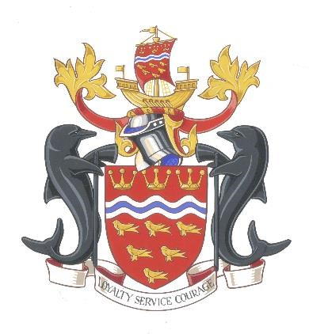
https://www.esfrs.org/about-us/publication-of-information/financial-information/

EAST SUSSEX FIRE AUTHORITY AUDIT AND INSPECTION OF ACCOUNTS

ACCOUNTS FOR THE YEAR ENDED 31ST MARCH 2023

LOCAL AUDIT AND ACCOUNTABILITY ACT 2014

ACCOUNTS AND AUDIT REGULATIONS 2015

ACCOUNTS AND AUDIT (AMENDMENT) REGULATIONS 2022

Under Regulation 10 paragraph (1)(a) of The Accounts and Audit Regulations 2015, the Fire Authority must publish its Statement of Accounts together with any certificate or opinion, entered by the local auditor in accordance with section 20(2) of the Act, by 31 July. The Accounts and Audit (Amendment) Regulations 2022 changed this date to 30th September.

The external audit of the draft Statement of Accounts for the year ended 31 March 2023 has not yet been started by our external auditors, Ernst & Young (EY) LLP. EY is awaiting the outcome of discussions being led by the Department for Levelling Up, Housing & Communities (DLUHC) to resolve a national backlog of audits of local authorities (including fire authorities).

This situation is allowed for by Regulation 10, paragraph (2)(a) of the Accounts and Audit Regulations 2015 and the Accounts and Audit (Amendment) Regulations 2022.

(http://www.legislation.gov.uk/uksi/2015/234/regulation/10/made).

The Accounts and Audit (Amendment) Regulations 2022 (legislation.gov.uk)

Therefore this notification explains, as per paragraph (2)(a), that we are not yet able to publish our audited 2022/23 final statement of accounts in line with the statutory deadline of 30th September 2023, as per paragraph (1). Unaudited draft accounts were published on our website on 31 May 2023 and remain available at:

https://www.esfrs.org/about-us/publication-of-information/financial-information/

Our audited final statement of accounts for 2022/23 will published as soon as reasonably practical after the conclusion of the audit and receipt of EY’s Audit Results Report.

Duncan Savage,
Treasurer
East Sussex Fire Authority,
East Sussex Fire and Rescue Service Headquarters
Church Lane
Lewes
East Sussex
BN7 2DZ

Email: duncan.savage@esfrs.org

