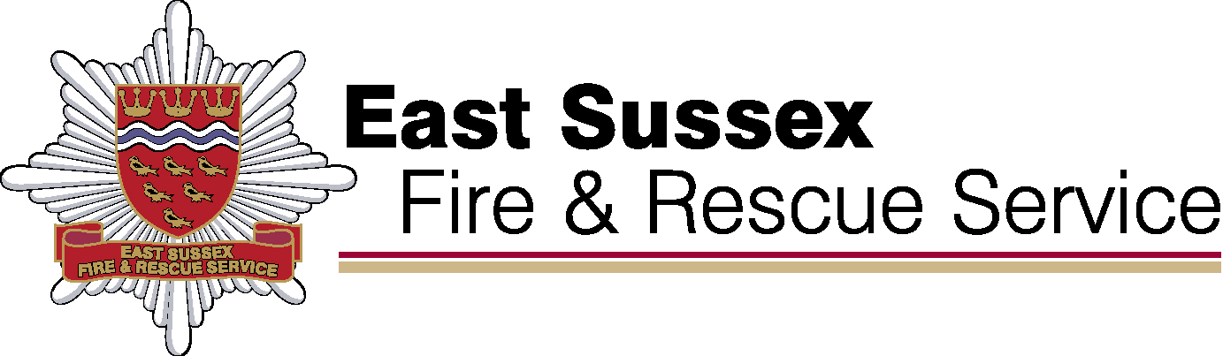

**East Sussex Fire & Rescue**

**Performance Results**

**Quarter 4 and year end results 2021/22**

JULY 2022

**Our Purpose**

**We make our communities safer**

**We will do this by: Commitment 1: Delivering high performing services**







**We make our communities safer**

**We will do this by:**

**Commitment 2: Educating our communities**



**We make our communities safer**

**We will do this by:**

**Commitment 3: Developing a multi-skilled, safe and valued workforce**



**We make our communities safer**

**We will do this by:**

**Commitment 4: Making effective use of our resources**

