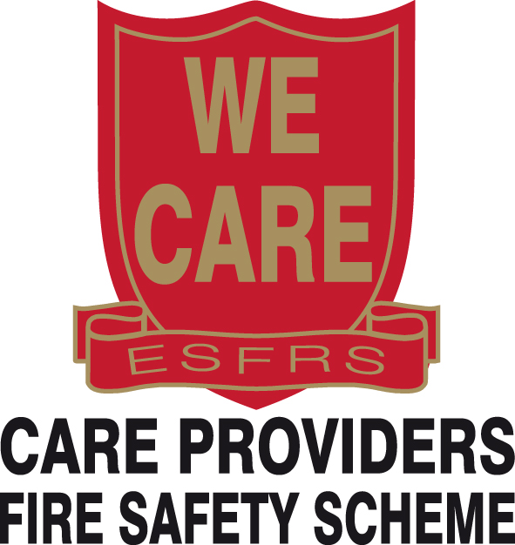 Referral Form
(To be emailed)
Name
Organisation Address
Postcode
Telephone number
Client’s details:
Millbrook client ID (essential if referring following prescription of a Dynamic Airflow Device)
Estimated date Dynamic Airflow device will be delivered
Name
Address
Postcode
Telephone number
The client understands that the home safety visit provided by East Sussex Fire & Rescue Service is completely FREE of charge and consent been given Yes

Fire risk factors (please tick all that apply):
80 years or older |  | Sight impaired
65 years or older |  | Smoker
Lives alone |  | Hearing impaired
Is there anyone in premises with pacemaker? |  | Is there anyone in premises with Epilepsy?
Reduced mobility/immobile |  | Suffering mental health issue (e.g. Dementia) Please state:
History of trips/falls |  | A single parent (with one or more children 0-5 years age)
Long-term medication/sedatives |  | Victim of arson or threats of arson
Occupier has no working smoke alarms |  | Victim of domestic violence and/or hate crime
Previous fire incident |  | Heavy alcohol consumption
History of fire setting in own dwelling |  | Hoarding in the premises  Please state clutter rating:
Property Privately Owned |  | No Lone Working to Premises:  Please state reason:
Property Privately Rented |  | No Lone Working to Premises:  Please state reason:
Property Owned by Housing Ass / Council
Please State:
Comments:

Health prescribers should email this form via secure (nhs.net) email to:
DMHRC.Fire-EastSussex@nhs.net
ASC prescribers should email this form, via the Voltage system to:
care.providers@esfrs.org
Home Safety Visits Tel: 0800 177 7069
East Sussex Fire and Rescue Service will use the information provided by you to assist us in ensuring you receive best advice on fire safety. This data may also be used for statistical purposes locally to assist us in improving community fire safety and nationally for Government policy. Full details of what we do with your data and the rights which you have in relation to that data, are available in our Privacy Notice. You can request a copy to be sent to you by our representative or by contacting us at the Community Safety Department, East Sussex Fire & Rescue Service, Eastbourne Community Fire Station, Whitley Road, Eastbourne, East Sussex, BN22 8LA or telephone: 0800 177 7069. Alternatively you can view the ESFRS Privacy Policy at www.esfrs.org/privacynotice

