Arson Risk Assessment
For small businesses

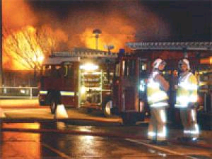
Don’t become an
arson statistic!

Each year there are over 3,100 arson attacks on shops , cafes and small businesses (1). It is estimated that up to 80% of businesses are seriously affected following a major fire (2).

1 UK fire Statistics 2003, Office of Deputy Prime Minister
2 London Chamber of Commerce Statistics 2003

Name of Premises:

Name of responsible person:

Name of person carrying out Risk Assessment:

Signature:

Date:

 | Signal Crime | Yes | No
1 | Is there a history of vandalism or fire setting in the area around the premises?

 | Security | Yes | No
2 | Is security lighting provided?
3 | Is a CCTV system installed?
4 | Are all external doors, roof lights and windows secured out of business hours?
5 | Are waste containers locked when not in use?
6 | Are waste containers secured so they cannot be moved and placed against the property?
7 | Do letter boxes have metal containers on the inside to contain lighted rags, paper or fireworks?
8 | Do staff monitor customer or visitor movements?

 | Waste Removal | Yes | No
9 | Is waste regularly removed by the local authority or a contractor?

 | Fire Safety Management | Yes | No
10 | Is the premises fitted with smoke alarms or other means to give early warning of fire?

To reduce the risk of an arson attack any of the highlighted areas receiving a tick will require a control measure to be put in place. The outcomes of this arson risk assessment should be included in the overall fire risk assessment, if one Is required, and action plan.
Headquarters

Any other issues?

This risk assessment is to be reviewed in line with your current Fire Risk Assessment or following any significant change or incident

For FREE fire safety advice, visit our web site or contact

Tel: 08001777069
E.Mail: airt@esfrs.org

East Sussex Fire & Rescue Service

Community Safety
Whitley Road
Eastbourne
East Sussex
BN22 8LA

All information collected will be held securely and not passed on to any third parties

